**EasyServe**

**Multi-Purpose and Multi-Functional**

**Application system for Dine-In Environment**

**Final Year Project**



**Project Primary Advisor**

Ma’am Saara Asif

**PROJECT SECONADRY ADVISOR:**

Sir Gadhuan Aslam

**PROJECT TEAM:**

Dawood Suleman Sahi – 021-10472

Hashim Riaz – 021-10202

Numair Bin Mehmood – 020-11237

Department of Computer Science

**Forman Christian College (A Chartered University)**

# EasyServe

**By**

**Numair Bin Mehmood**

**Hashim Riaz**

**Dawood Suleman Sahi**

Project submitted to

Department of Computer Science,

Forman Christian College (A Chartered University),

Lahore, Pakistan.

In partial fulfillment of the requirements for the degree of

**BACHELOR OF SCIENCE**

**IN**

**COMPUTER SCIENCE (Honors)**

Primary Project Advisor Secondary Project Advisor

Senior Project Management Committee Representative

**Abstract**

This project is aimed at developing an online multi-functional, multi-purpose dining system that is of importance to the food industry. This system is a web-based application that will be accessed through tabs wherever the system is implemented. This system will automate the workflow and the room for human error will be net to none. There are features like online ordering, food review, live stream your order and tracking the status of the order.

## Acknowledgement

We owe our deep gratitude to our project guide Ma’am Saara Asif and our secondary advisor Sir Gadhaun who took keen interest on our project work and guided us all along, till the completion of our project work by providing all the necessary information for developing a good system.

**List of Figure**

Figure 1: Use Case Diagram 20

Figure 2: UML Diagram 23

Figure 3: Sequence Diagram 24

Figure 4: ERD Diagram 25

Figure 5: System Architecture 26

Figure 6: External Entities 29

Figure 7: Workflow Diagram 30

Figure 8: Login Page 31

Figure 9: Registration Screen 32

Figure 10: Customer Dashboard 33

Figure 11: Order Screen 34

Figure 12: Cancelled Order 35

Figure 13: Delivered Orders 36

Figure 14: Feedback Screen 37

Figure 15: Live Feed 38

Figure 16: Edit Details 39

Figure 17: Blog Page 40

Figure 18: Create Confirm Order Screen 41

Figure 19: Live Chat Screen 42

Figure 20: Admin Dashboard 43

Figure 21: All Order Feed 44

Figure 22: Feedback/Reviews Screen 45

Figure 23: User Verification Screen 46

Figure 24: Login Page (Appendix) 62

Figure 25: Registration Page (Appendix) 63

Figure 26: Logo (Appendix) 64

Figure 27: Logout Icon (Appendix) 64

Figure 28: Side Toolbar (Appendix) 65

Figure 29: Ordering an Item (Appendix) 66

Figure 30: Confirm Order (Appendix) 66

Figure 31: Payment Method (Appendix) 67

Figure 32: Delivered Order (Appendix) 68

Figure 33: Feedback Screen (Appendix) 69

Figure 34: Live Feed (Appendix) 70

Figure 35: Edit Details (Appendix) 71

Figure 36: Facebook Page 72

Figure 37: Instagram Page 72

Figure 38: Blog (Appendix) 73

Figure 39: Admin Dashboard (Appendix) 74

Figure 40: User Verification (Appendix) 75

List of Tables

Table 1: UC-1 Sign Up (Admin) 10

Table 2: UC-2 Sign Up (User) 11

Table 3: UC-3 Login as User 12

Table 4: UC-4 Login as Admin 13

Table 5: UC-5 Manage Menu 14

Table 6: UC-6 Manage Chef 15

Table 7: UC-7 Place Order 16

Table 8: UC-8 Food Tracking 17

Table 9: UC-9 Feedback 18

Table 10: UC-10 Chef Login 19

Table 11: UC-11 Accept Orders 20

Table 12: UC-12 Chef Timeout 21

Table 13: Pros and Cons of XAMPP 22

Table 14: Pros and Cons of Live IP Cam 23

Table 15: Pros and Cons of Database 24

Table 16: Pros and Cons of E-Devices 25

Table 17: TC-1 Sign Up (Admin) 26

Table 18: TC-2 Sign Up (User) 27

Table 19: TC-3 Login Successful 28

Table 20: TC-4 Unsuccessful Login 29

Table 21: TC-5 Add item in Menu 44

Table 22: TC-6 Manage Chef 45

Table 23: TC-7 Order Placement 45

Table 24: TC-8 Tracking 46

Table 25: TC-9 Feedback 46

Table 26: TC-10 Billing 70

## TABLE OF CONTENTS

**ABSTRACT................................................................................................................................. III**

**ACKNOWLEDGEMENT.......................................................................................................... IV**

**LIST OF FIGURES..................................................................................................................... V**

**LIST OF TABLES....................................................................................................................... VI**

**CHAPTER 1.** **INTRODUCTION ................................................................................................ 1**

1.1 INTRODUCTION .............................................................................................................. 2 1.2 OBJECTIVES ..................................................................................................................... 3 1.3 PROBLEM STATEMENT ................................................................................................. 4 1.4 SCOPE ................................................................................................................................ 5

**CHAPTER 2.** **REQUIREMENTS ANALYSIS........................................................................... 6**

2.1 LITERATURE REVIEW ..................................................................................................... 6 2.2 USER CLASSES AND CHARACTERISTICS .................................................................. 7 2.3 DESIGN AND IMPLEMENTATION CONSTRAINTS..................................................... 7 2.4 ASSUMPTIONS AND DEPENDENCIES.......................................................................... 7 2.5 FUNCTIONAL REQUIREMENTS ................................................................................... 8 2.6 USE CASE DIAGRAM .................................................................................................... 20 2.7 NONFUNCTIONAL REQUIREMENTS ........................................................................ 21 2.8 OTHER REQUIREMENTS ............................................................................................. 21

**CHAPTER 3.** **SYSTEM DESIGN ............................................................................................. 22**

3.1 APPLICATION AND DATA ARCHITECTURE............................................................ 22 3.2 COMPONENT INTERACTIONS AND COLLABORATIONS ..................................... 23 3.3 SYSTEM ARCHITECTURE ........................................................................................... 26 3.4 ARCHITECTURE EVALUATION.................................................................................. 27 3.5 COMPONENT-EXTERNAL ENTITIES INTERFACE ................................................. 29 3.6 SCREENSHOTS/PROTOTYPE ...................................................................................... 30 3.7 OTHER DESIGN DETAILS............................................................................................. 47

**CHAPTER 4.** **TEST SPECIFICATION AND RESULTS....................................................... 48**

4.1 TEST CASE SPECIFICATION ....................................................................................... 48 4.2 SUMMARY OF TEST RESULTS.................................................................................... 58

**CHAPTER 5.** **CONCLUSION AND FUTURE WORK .......................................................... 59**

### 5.1 PROJECT SUMMARY....................................................................................................... 59 5.2 PROBLEMS FACED AND LESSONS LEARNED .......................................................... 60 5.3 FUTURE WORK............................................................................................................... 60

**REFERENCES ............................................................................................................................ 61**

**APPENDIX a** **GLOSSARY......................................................................................................... 61**

**APPENDIX B** **DEPLOYMENT/INSTALLATION GUIDE................................................... 62**

**APPENDIX C** **USER MANUAL ............................................................................................... 62**

**APPENDIX D** **STUDENT INFORMATION SHEET.............................................................. 76**

**APPENDIX E** **PLAGIARISM FREE CERTIFICATE ........................................................... 77**

**APPENDIX F** **PLAGIARISM REPORT .................................................................................. 78**

### Revision History

|  |  |  |  |
| --- | --- | --- | --- |
| **Name** | **Date** | **Reason For Changes** | **Version** |
|  |  |  |  |
|  |  |  |  |

### 

### Chapter 1. Introduction

#### 1.1 Introduction

Web application can be considered as a self-service technology and in today’s world these applications are the way to go. Significance of using these is that a user does not have to install any additional applications, and they can use the web address anywhere and anytime. We can see an ever-growing importance of self- service tech, and an application which enables users to interact freely over remote access is a need of the hour. This enables individuals such as introverts to communicate easily with the desired restaurants. Facing a global pandemic just emphasizes the fact that this service is called for. If we look at giant world companies like McDonalds, we see them adopting services like these that minimizes human contact and move towards contactless services. Our idea is to create a web based interactive system through which we are able to offer complete satisfaction to the customer about their meal. This includes ordering food through online menu and placing a custom order which can be directly transferred to the chef. It also reduces the communication gap. Services like tracking your order and viewing your food being made will be provided in this application. It will create transparency which will further help in building trust between companies and customers. This web application is designed to cater all kinds of needs, such as ordering food in a restaurant, checking status update and monitoring food quality through live stream. This paper describes every aspect of this web application in detail.

Web application can be designed for a wide range of use. Many organizations and even individuals use it for numerous reasons as it helps to make things easy and more efficient. Web applications serve as multi-purpose as everyone can access it with the increase in internet usage. From dining services to delivery to online shopping carts; web apps are being used everywhere. If we talk about web app for dining purpose, there are tons of benefits and answers to why there's been a shift towards usage of web application.

Companies like Pizza Hut, McDonalds and Burger King have started self-order dining service and it has made it easier to order especially during this period where maintaining social distance is of the utmost priority. Another company known as Food Panda which specializes in delivery services have contactless interactive web and app-based system. They deliver food from one restaurant to the customer's doorstep, and even have payment option through banks. Just like social media, web app will serve as a medium where anyone who has a mobile phone can access it and take advantage of the features it provides. This web application makes it easy for every individual to order or even look at the menu. All they have to do is open their phones and look through it rather than having a waiter by your side telling you about the menu. Many people shy away from communicating and this application will be a great way for them to interact freely. Our web application will have an option of live streaming, this way we hope to cancel out the thought most of us face which is food quality and cleanliness. Through recent reports from the Food Authority of Pakistan, it has been observed that unhygienic food is being offered by well-known restaurants in Pakistan, which has led people not to trust these organizations. Hygiene is a top priority when you are paying substantial amount of money for your food. Imagine enjoying food from your favorite restaurant and suddenly getting the news of the restaurant being sealed due to bad hygienic conditions.

Most of us have different preferences when it comes to food, this application will help overcome the communication gap and will let you customize your order the way you like it. It can be done either by mentioning on the web app or by having a talk with kitchen chef/head through this web app service. If we talk about the current situation that is COVID- 19, this web app will help in making the system completely contactless and there will be no need of human interaction as everything will be completely done through this web app including giving reviews. This web app will also give a perquisite to the business which is systematic backing of the data. This data includes orders, reviews and even suggestions

#### 1.2 Objectives

Our objective is to create a system through which we can provide complete satisfaction to the customer about their food. Our application is called Easy Serve in which the customer will have an option to view the food completely by showing its live streaming .Due to some of the rumors regarding the food industry about unhygienic food served by the restaurants we decided to provide our customers a new experience of their food by giving them satisfaction that their food is hygienic and is completely in safe hands by giving the new option of live streaming which will allow them to view the live cooking of the food.

The goal of our project is to provide a platform that is interactive and contactless for the customers. It would give freedom to the customer for individualized order and give special feedbacks. Another goal is to have systematic data of customers including reviews and feedback which will be backed up. This will allow companies to improve their services in future. Not only would this application be beneficial in the current situation, it will allow individuals all around to be technology efficient and will be cost effective.

* Interactive System for the Food Industry & Consumers
* -Live Interactive Support & Status Update
* -Interactive Menu & Self Order Facilitation
* -Contact Less, in house Facilitation
* -Customer Ease, Support & Satisfaction
* -Feedback & Review

#### 1.3 Problem Statement

The restaurant protocols require customers to rely on their attending waiters for the correct menu. This leaves room for mismanagement and a chaotic situation. However, using our application would enable customers to bridge the gap between themselves and the chef and "right-menu" will be availed. Miscommunication or "order mix-up" would be reduced with improved customer satisfaction. Our application stands to gain considerable recognition as an industry trend setter in terms of value and convenience.

#### 1.4 Scope

The project & its main scopes are as follows: (note: these do not cover all functionalities & support features. please do refer to the attached document)

-- A Multi-Purpose, Multi-Functional, User Interactive System for Dine-In Environment -- *Management & Customer Ease through a (Human) Contact-less - Web Based Interactive System

* Interactive System for the Food Industry & Consumers

* Customer Service Facilities & Ease Support

* Business Service Facilities & Quality Assurance

* Business Marketing & Promotional Support

### Chapter 2. Requirements Analysis

#### 2.1 Literature Review

While working on the food ordering process around the world, several approaches were considered. Many wireless systems such as FIWOS, WOS and i-menu systems were developed. These systems mentioned were all PDA based. The significance of using PDA based system was that it allowed customers to key in their ordering process and allowed increase in restaurants expenditures. However, it did not allow any real time feedback from customers and the PDA interface was unappealing.

One of the most widely used conventional system for food ordering is when the customers walk in a restaurant, sit in and the waiter brings them the paper-based menu. This process solely requires the customers to be seated in the given place and the waiter to be on the lookout to assist the ordering process. The cons of having paper-based systems are huge amounts of human efforts, wastage of money, time, and paper. A single mistake would mean changing the whole menu card and re-printing it again from scratch.

Another method is self-service restaurant, where the customers have to pick their order before being presented at the counter. The menu card is usually displayed behind the counter and it allows the customers complete autonomy to make decisions without facing the hassle of waiters.

Furthermore, a new approach known as multi touch technology was introduced in which the user had full authority to perform different operations instantaneously. The elements needed for this technology were tabletops and wall-screen which allows multiple users sharing the same display. However, there are certain limits to this kind of technology. Multi touch requires costly, resistive screens which are sometimes not operable with stylus until or unless it is of conductive material. Due to the screen being expensive, I offers less durability and short life. Another con is screens have poor visibility in direct sunlight and may be effected by large amounts of dirt and dust; which results in overall high maintenance and huge sums of money to be invested

#### 2.2 User Classes and Characteristics

1. Admin login
2. Admin logout
3. Manage table
4. Manage menu
5. Manage chef
6. Place order
7. Track food
8. Rating Food hygiene
9. Chef login
10. Check orders
11. Chef logout

#### 2.3 Design and Implementation Constraints

Maintaining the system could be a problem for the restaurant if they would want to edit and make changes frequently. But this problem can be eradicated if they hire someone who can edit whatever and whenever they want.

#### 2.4 Assumptions and Dependencies

• Web Domain

• Web Server

• Theme Support

• Generic Support Plugins

In this system we’ll have devices through which the order will be placed , the live streaming will be done with( IP cameras), which will be connected all over the kitchen, every platform of the restaurant will have an order generating system software which will tell the staff which order is being cooked on at the current moment.

**2.5 Functional Requirements**

#### Sign Up (Admin)

|  |  |  |  |
| --- | --- | --- | --- |
| **Identifier** | | UC-1 | |
| **Purpose** | | To allow Admin to register | |
| **Priority** | | High | |
| **Pre-conditions** | | The user must be connected to the internet | |
| **Post conditions** | | Admin will be registered and can use the website by just logging in through saved username and password | |
| **Typical Course of Action** | | | |
| **S#** | **Actor Action** | | **System Response** |
| **1** | Open application | | Presents the main page |
| **2** | Click sign up for admin | | Presents sign up form |
| **3** | The user fills the form and click submit | | Checks credentials and takes the admin to admin dashboard |
|  |  | |  |
| **Alternate Course of Action** | | | |
| **S#** | **Actor Action** | | **System Response** |
| **1** | Opens Application | | Presents the main page |
| **2** | Click sign up | | Presents signup form |
| **3** | The user fills the form and click submit | | Checks credentials for verification |
| **4** | The user checks if the format was wrong or a field was invalid | | Tells user to make changes. |

**Table 1: UC-1 Sign Up (Admin)**

#### Sign Up (User)

|  |  |  |  |
| --- | --- | --- | --- |
| **Identifier** | | UC-2 | |
| **Purpose** | | To allow the users to sign up. | |
| **Priority** | | High | |
| **Pre-conditions** | | User should have a proper account details and internet access | |
| **Post conditions** | | User will be registered and can use the website by just logging in through saved username and password | |
| **Typical Course of Action** | | | |
| **S#** | **Actor Action** | | **System Response** |
| **1** | Open application | | Presents the main page |
| **2** | Click sign up for user | | Presents sign up form |
| **3** | The user fills the form and click submit | | Checks credentials and takes the user to the homepage |
| **…** |  | |  |
| **Alternate Course of Action** | | | |
| **S#** | **Actor Action** | | **System Response** |
| **1** | Opens Application | | Presents the main page |
| **2** | Click sign up | | Presents signup form |
| **3** | The user fills the form and click submit | | Checks credentials for verification |
| **4** | The user checks if the format was wrong or a field was invalid | | Tells user to make changes. |

**Table 2: UC-2 Sign Up (User)**

#### Login as user

|  |  |  |  |
| --- | --- | --- | --- |
| **Identifier** | | UC-3 | |
| **Purpose** | | To allow the users to sign in. | |
| **Priority** | | High | |
| **Pre-conditions** | | User should have a registered account and internet access | |
| **Post conditions** | | User is logged in and have access to the website. | |
| **Typical Course of Action** | | | |
| **S#** | **Actor Action** | | **System Response** |
| **1** | Opens application | | Presents main page |
| **2** | Enter login credentials | | Checks credentials |
| **3** | User has signed in | | Shows the home page |
| **…** |  | |  |
| **Alternate Course of Action** | | | |
| **S#** | **Actor Action** | | **System Response** |
| **1** | Open application | | Presents main page |
| **2** | Enter login credentials | | Check login credentials |
| **3** | Invalid credentials | | Asks to sign in again |
| **…** |  | |  |

**Table 3: UC-3 Login as User**

#### Login as Admin

|  |  |  |  |
| --- | --- | --- | --- |
| **Identifier** | | UC-4 | |
| **Purpose** | | To allow the admins to sign in. | |
| **Priority** | | High | |
| **Pre-conditions** | | User should have a verified registered account and internet access | |
| **Post conditions** | | Admin is logged in and now can manage its store on website through a dashboard | |
| **Typical Course of Action** | | | |
| **S#** | **Actor Action** | | **System Response** |
| **1** | Opens application | | Presents main page |
| **2** | Enter login credentials | | Checks credentials |
| **3** | Admin has signed in | | Shows the home page |
| **…** |  | |  |
| **Alternate Course of Action** | | | |
| **S#** | **Actor Action** | | **System Response** |
| **1** | Open application | | Presents main page |
| **2** | Enter login credentials | | Check login credentials |
| **3** | Invalid Credentials | | Ask to login again |
| **…** |  | |  |

**Table 4: UC-4 Login as Admin**

#### 

#### Manage Menu

|  |  |  |  |
| --- | --- | --- | --- |
| **Identifier** | | UC-5 | |
| **Purpose** | | Admin login to the website to add, delete and update the menu of their restaurants | |
| **Priority** | | High | |
| **Pre-conditions** | | Admin must be log in with correct id and password | |
| **Post conditions** | | Record of menu saved successfully | |
| **Typical Course of Action** | | | |
| **S#** | **Actor Action** | | **System Response** |
| **1** | Opens Application | | Presents main page |
| **2** | Enter Login credentials | | Check login credentials |
| **3** | Admin is signed in | | Shows admin dashboard |
| **4** | Admin select the option “Menu” | | Open menu dashboard |
| **5** | Admin select add button | | Opens a window to add a dish |
| **6** | Admin select add delete button | | Opens the menu to select the item to delete |
| **Alternate Course of Action** | | | |
| **S#** | **Actor Action** | | **System Response** |
| **1** | Opens website | | Presents main page |
| **2** | Enter login credentials | | Checks login credentials |
| **3** | Wrong credentials | | Asks user to login again |
| **4** | Admin select the option “Menu” | | Open menu dashboard |
| **5** | Admin does not select anything | | Ask user to select an option |

**Table 5: UC-5 Manage Menu**

#### Manage Chef

|  |  |  |  |
| --- | --- | --- | --- |
| **Identifier** | | UC-6 | |
| **Purpose** | | Admin login to the website and then add, delete and update the chef | |
| **Priority** | | High | |
| **Pre-conditions** | | Admin must login with correct id and password | |
| **Post conditions** | | Admin can successfully manage the chef | |
|  | **Typical Course of Action** | | |
| **S#** | **Actor Action** | | **System Response** |
| **1** | Opens Application | | Presents main page |
| **2** | Enter Login credentials | | Check login credentials |
| **3** | Admin is signed in | | Shows admin dashboard |
| **4** | Admin select the option “Manage Chef” | | Open chef dashboard |
| **5** | Admin select add button | | Opens a window to add a chef |
| **6** | Admin select add remove button | | Opens the menu to select the chef to remove |
| **7** | Admin select add update button | | Opens the menu to select the chef to update |
|  | **Alternate Course of Action** | | |
| **S#** | **Actor Action** | | **System Response** |
| **1** | Open website | | Presents login page |
| **2** | Enter login credentials | | Check login credentials |
| **3** | Invalid Login | | Ask admin to login again |
| **…** |  | |  |

**Table 6: UC-6 Manage Chef**

#### Place Order

|  |  |  |  |
| --- | --- | --- | --- |
| **Identifier** | | UC-7 | |
| **Purpose** | | Show the menu of selected restaurant to order | |
| **Priority** | | High | |
| **Pre-conditions** | | Customer should be logged in as a user | |
| **Post conditions** | | User can see the list and prices of the dishes | |
| **Typical Course of Action** | | | |
| **S#** | **Actor Action** | | **System Response** |
| **1** | Customer Starts to order on tablet | | Presents the menu of the restaurant |
| **2** | Customer will pick a free table | | Check if the table is vacant or not |
| **3** | Customer will confirm the table | | Shows the menu of the restaurant |
| **4** | User selects a meal to order | | Open a custom requirements page for user if they have any extra demand |
| **5** | User inputs the ingredients or request for something special | | The system will show the final order to user for review. |
|  | **Alternate Course of Action** | | |
| **S#** | **Actor Action** | | **System Response** |
| **1** | User enter invalid table | | Ask for user to pick a free table |
| **2** | User enter invalid ingredient | | Check if these instructions are valid |
| **3** | Wrong instructions | | Ask user to input valid request |
| **…** |  | |  |

**Table 7: UC-7 Place Order**

#### Food Tracking

|  |  |  |  |
| --- | --- | --- | --- |
| **Identifier** | | UC-8 | |
| **Purpose** | | Customers have the choice to trach their food through the website | |
| **Priority** | | High | |
| **Pre-conditions** | | Customer first place the order | |
| **Post conditions** | | Customer successfully tracks it’s order | |
| **Typical Course of Action** | | | |
| **S#** | **Actor Action** | | **System Response** |
| **1** | Open tracking page | | Website shows tracking page |
| **2** | Customer selects it’s chef | | Check if it’s the right chef |
| **3** | Customer will select live feed option | | Shows the live feed of the kitchen |
| **Alternate Course of Action** | | | |
| **S#** | **Actor Action** | | **System Response** |
| **1** | If customer selects invalid chef | | System will ask for the right chef |
| **2** | If order have not been placed by customer and they ask for  tracking | | Check if order if placed and ask the customer to first order their meal |

**Table 8: UC-8 Food Tracking**

#### Feedback

|  |  |  |  |
| --- | --- | --- | --- |
| **Identifier** | | UC-9 | |
| **Purpose** | | Customer gives feedback to the chef and restaurant | |
| **Priority** | | High | |
| **Pre-conditions** | | Customer have placed an order first | |
| **Post conditions** | | Customer will successfully rate about their food | |
|  | **Typical Course of Action** | | |
| **S#** | **Actor Action** | | **System Response** |
| **1** | Customer wants to give feedback | | Website will prompt feedback Button |
| **2** | Customer will give the feedback | | Check the feedback |
| **3** | Customer will give the rating | | Check if the rating is good or not |
| **4** | Customer wants to record a complain | | Forward the complaint to the chef and assure customer satisfaction |
|  | **Alternate Course of Action** | | |
| **S#** | **Actor Action** | | **System Response** |
| **1** | No alternate course | |  |

**Table 9: UC-9 Feedback**

#### Chef Login

|  |  |  |  |
| --- | --- | --- | --- |
| **Identifier** | | UC-10 | |
| **Purpose** | | Chef can login into the application to check their orders and select them | |
| **Priority** | | High | |
| **Pre-conditions** | | Chef should have valid id and password | |
| **Post conditions** | | Chef is successfully logged in | |
| **Typical Course of Action** | | | |
| **S#** | **Actor Action** | | **System Response** |
| **1** | Chef opens the website | | Presents login page |
| **2** | Enter login credentials | | Checks credentials |
| **3** | Chef has signed in | | Shows the chef dashboard |
| **Alternate Course of Action** | | | |
| **S#** | **Actor Action** | | **System Response** |
| **1** | Open application | | Presents login page |
| **2** | Enter login credentials | | Check login credentials |
| **3** | Wrong credentials | | Ask to login again |

**Table 10: UC-10 Chef Login**

#### Accept Orders

|  |  |  |  |
| --- | --- | --- | --- |
| **Identifier** | | UC-11 | |
| **Purpose** | | After login chef will accept the orders of the customers | |
| **Priority** | | Medium | |
| **Pre-conditions** | | Chef must login as a chef | |
| **Post conditions** | | Chef accepts the order. | |
| **Typical Course of Action** | | | |
| **S#** | **Actor Action** | | **System Response** |
| **1** | Chef wants to accept order | | Check if order is available |
| **2** | Press accept button | | Shows the order details |
| **3** | Review special requests | | Shows the request from the customers |
| **4** | Live feed | | Shows the live feed of the kitchen to the customer |
| **Alternate Course of Action** | | | |
| **S#** | **Actor Action** | | **System Response** |
| **1** | Accepts wrong order | | Present with error |

**Table 11: UC-11 Accept Orders**

#### Chef Timeout

|  |  |  |  |
| --- | --- | --- | --- |
| **Identifier** | | UC-12 | |
| **Purpose** | | Chef will timeout from the application after the completion of the day’s order | |
| **Priority** | | High | |
| **Pre-conditions** | | Chef must be able to complete required orders | |
| **Post conditions** | | Chef successfully logout | |
| **Typical Course of Action** | | | |
| **S#** | **Actor Action** | | **System Response** |
| **1** | Chef logout | | Check if it’s possible |
| **2** | Check order | | Checks if the day’s order are complete |
| **3** | Select logout button | | Directs to main page of website |
|  | **Alternate Course of Action** | | |
| **S#** | **Actor Action** | | **System Response** |
| **1** | Chef logout | | Check if day goal is met |
| **2** | Not completed orders | | Ask chef to complete remaining order |

**Table 12: UC-12 Chef Timeout**

#### 2.6 Use Case Diagram

• Use Case Diagram

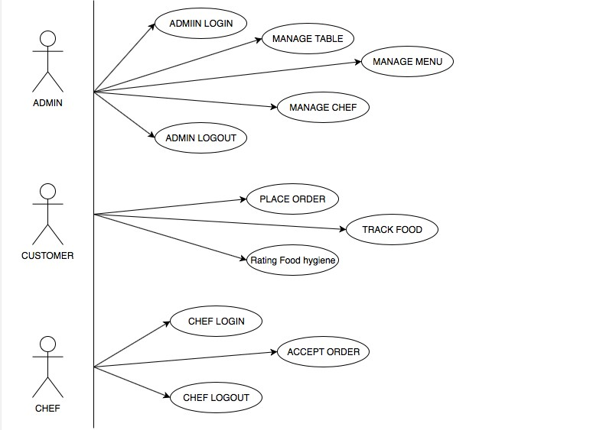

*Figure 1: Use Case Diagram*

#### 2.7 Nonfunctional Requirements

**2.7.1 Performance Requirements**

* Scalability:

The priority for the website scalability will be high as the website will be updated on weekly or monthly basis depending on the errors and bugs found. The website will be upgraded with new features with passage of time and through the feedback from the customers and restaurants. To resolve different issues a feedback portal will be provided to enhance the experience of the website.

* Performance:

In terms of performance the response time will be monitored and will be minimum. The system will run on personal server or internet server. The loading and refresh rate will be reduced so the customer or the restaurants admin does not have to wait.

**2.7.2 Security Requirements**

* **Security:**

The data of the individual (Customer or Admin) will be kept confidential and no unauthorized personal will be able to access it. The web application will be password protected so no one will be able to access the data.

* **Recoverability:**

If the website faces any error, it will be able to recover by itself and will run on web browsers. To make the user experience better the website will be able to recover from any errors caused during usage.

* **Integrity of the Data:**

When the web application will be updated with time, no one will be able to change any data except the person having the login credentials which will be monitored and different level of access will be given to the users (Customers, Admin & Chef)

**2.7.3 Additional Software Quality Attributes**

* **Usability:**

The Web application will be user friendly and easy to use for anyone. The application will be made in a way so that it will be easy to handle with friendly and attractive user interface. The different users will be able to manage their accounts with ease.

* **Maintainability:**

All data of clients (Customers, Admins & Chef) will be maintained through a database to keep track of the activity. As well as all the functionality and activity will be maintained daily.

### Chapter 3. System Design

#### 3.1 Application and Data Architecture

* **Web Based Application:** The first component of our project is the web app itself. It consists of the complete user interface and the services offered by this we application.
* **Server:** This component will handle all the requests that come from the users and will deliver responses accordingly. Basically this is the component where everything is processed and actions will be taken. This will include the integration of the live video feature which will allow the users to have a live feed of the kitchen.
* **Live Video/ Chat:** Next component is the live chat and video feature that will allow the users to have a new experience. This feature will be integrated with the system.
* **Database:** The final component is the database which is used to store all information such as user information, reviews, orders placed and all the data that is important for the features of the web app to work properly.

**These are the main components of are application. Interaction between these components and their working is mentioned in appropriate section.**

#### 3.2 Component Interactions and Collaborations

* **UML diagram**

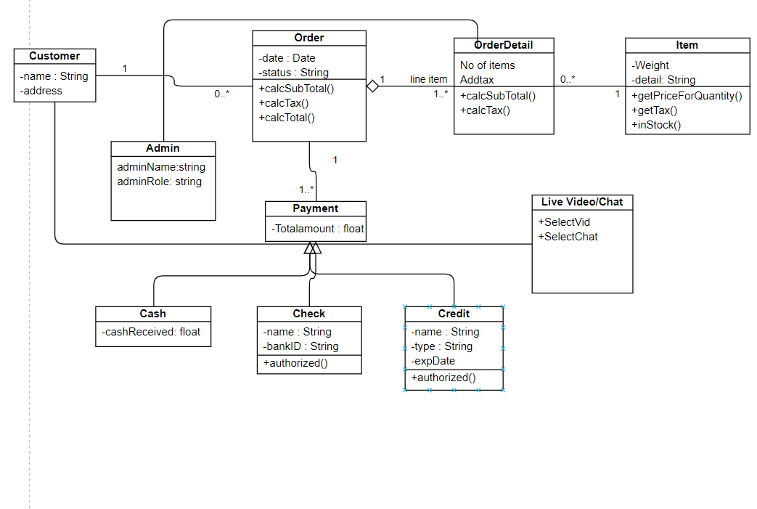

*Figure 2: UML Diagram*

* **Sequence Diagram**

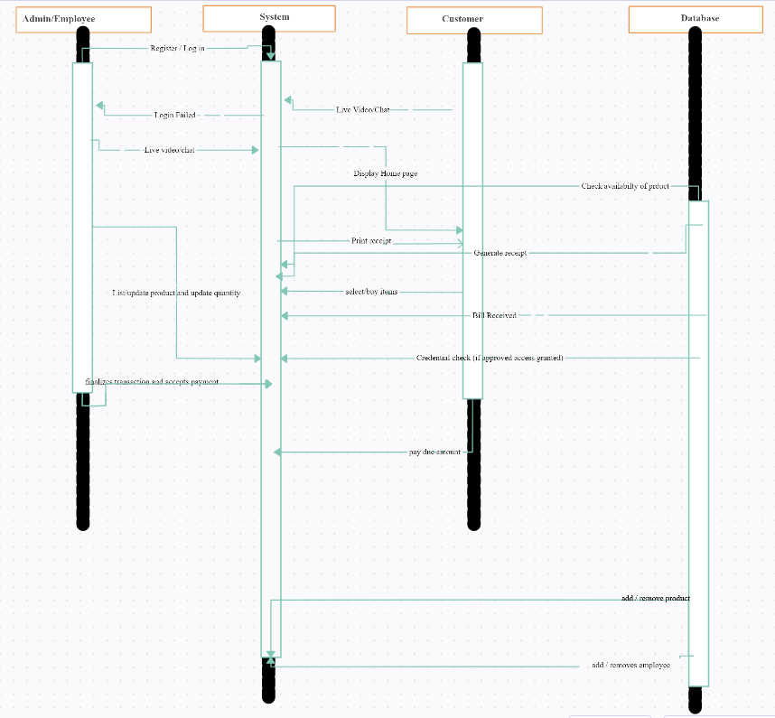

*Figure 3: Sequence Diagram*

* **ERD Diagram**

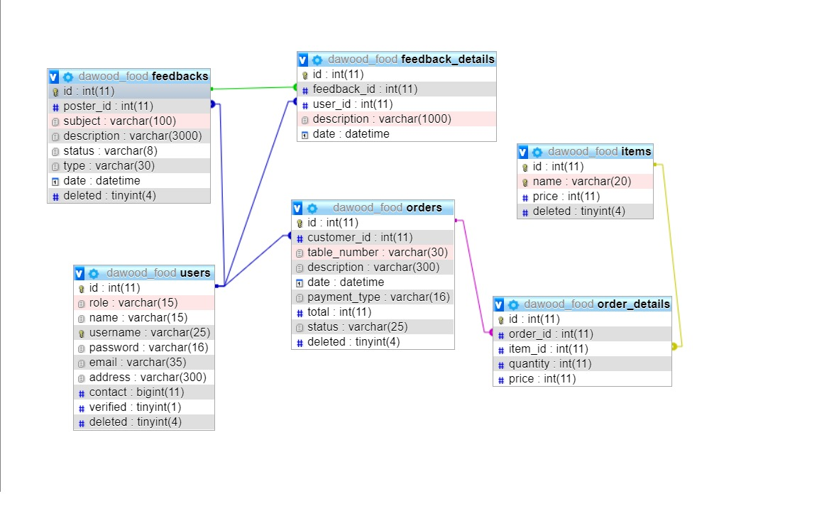

***Figure 4: ERD Diagram***

**3.3 System Architecture**

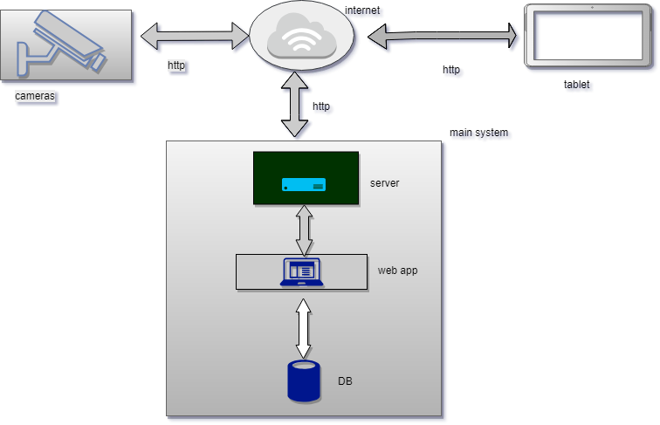

***Figure 5: System Architecture***

#### 3.4 Architecture Diagram Architecture Evaluation

**Hosting (XAMPP)**

|  |  |
| --- | --- |
| **Pros** | **Cons** |
| 1. Better Efficiency 2. Stable Connection | Local Host Environment  No live internet-based Database and Connections |

Table 13: Pros and Cons of XAMPP

**Live IP Cam**

|  |  |
| --- | --- |
| **Pros** | **Cons** |
| 1. Live IP based web streaming 2. Ease Of Access | 1. Security Concerns 2. Limited Access to IP Webcam Services (Free/Limited Version) |

**Table 14: Pros and Cons of Live IP Cam**

**Database**

|  |  |
| --- | --- |
| **Pros** | **Cons** |
| 1. Live-time Backend Support 2. Backend Optimizations & Configuration Support   . | 1. Security Risk 2. Bandwidth Usage |

**Table 15: Pros and Cons of Database**

**E-Devices**

|  |  |
| --- | --- |
| **Pros** | **Cons** |
| 1. Ease of Access 2. Efficient Accessibility 3. Access through E-Devices i.e., Mobile Devices & Tablets | 1. Less Human Interaction |

**Table 16: Pros and Cons of E-Devices**

**3.5 Component-External Entities Interface**

The following are external entities that are being used as external components in relation to the project prototype.

* Restaurants / Hotels & Similar Organizations
* Web Hosting Server & Database
* IP Camera & Security Service Providers
* Payment Portals & Authenticators

#### These External Components & Entities, their factors & involvement as either a first, second or third-party component / service serves directly for the complete functionality & working of the application system.

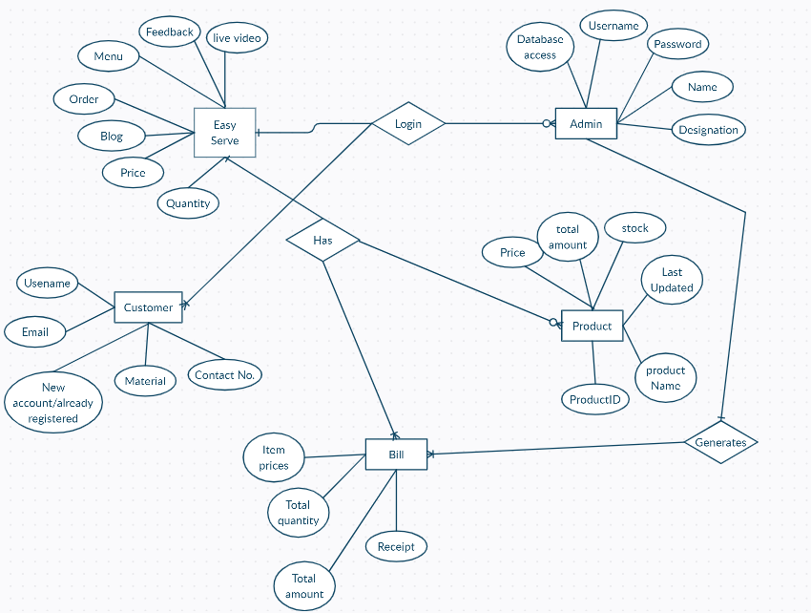

***Figure 6: External Entities***

#### 3.6 Screenshots/Prototype

**3.6.1 Workflow**

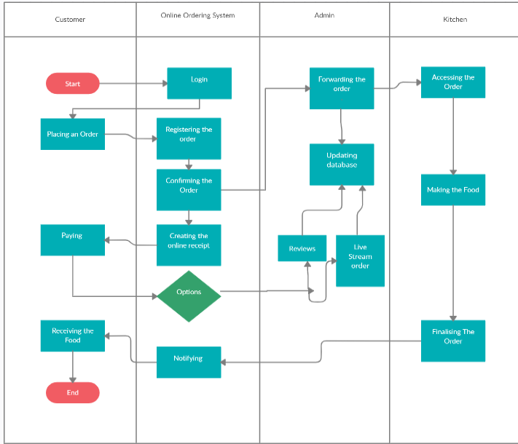>

***Figure 7: Workflow Diagram***

**3.6.2 Screens**

* 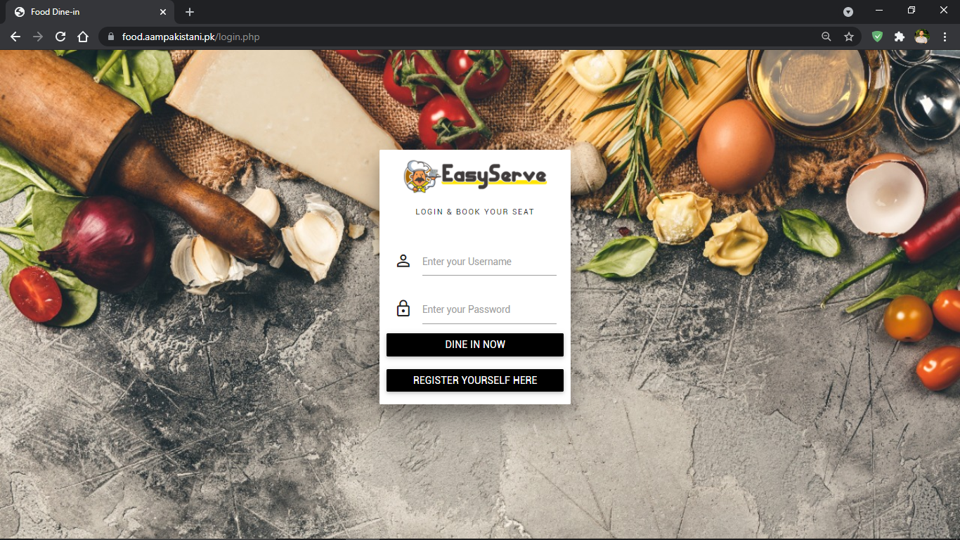**Login Page**

***Figure 8: Login Page***

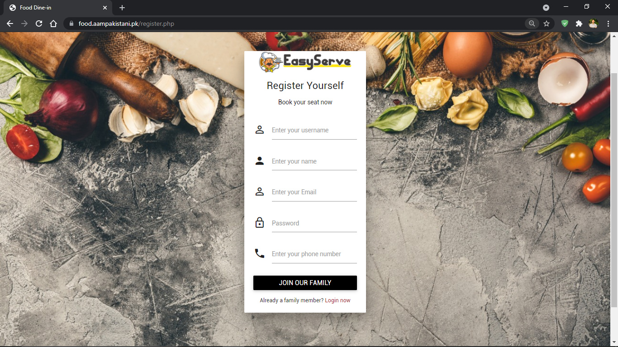

* **Registration Screen**

***Figure 9: Registration Screen***

* **Customer Dashboard**

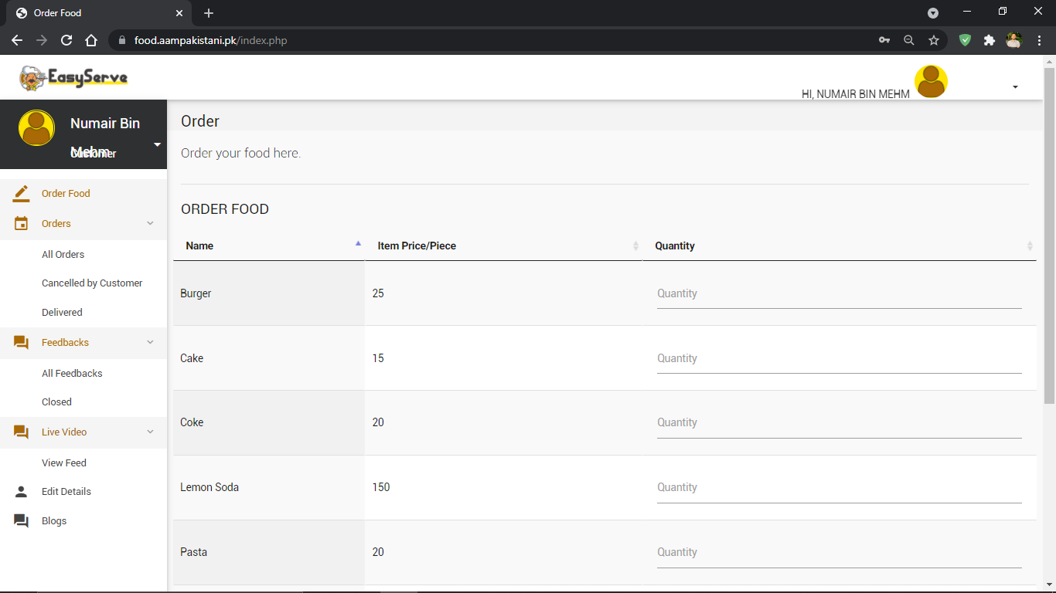

***Figure 10: Customer Dashboard***

#### 

* **Order Screen**

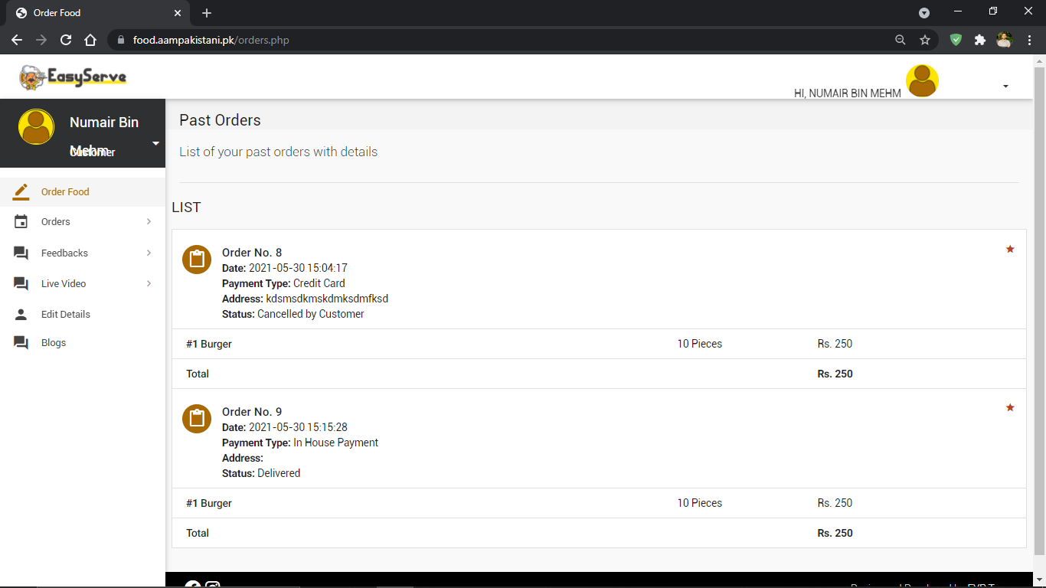

***Figure 11: Order Screen***

* **Cancelled Orders**

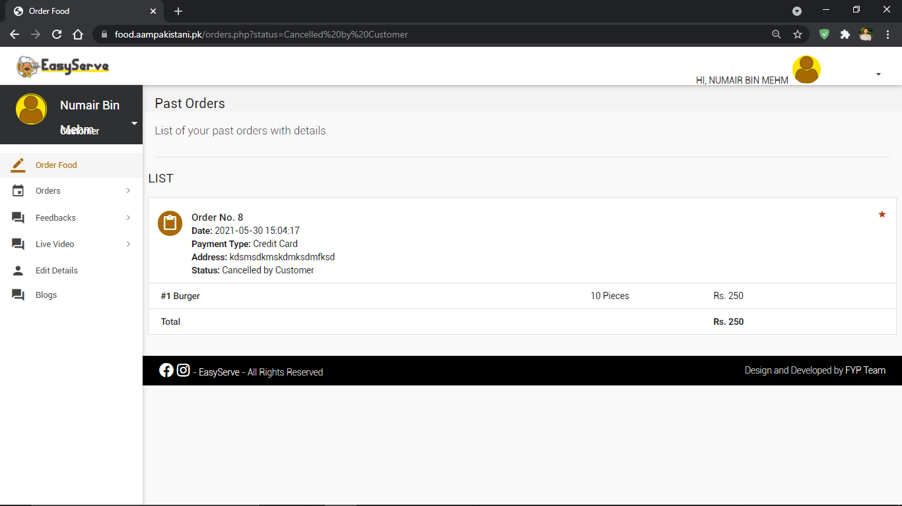

***Figure 12: Cancelled Order***

* 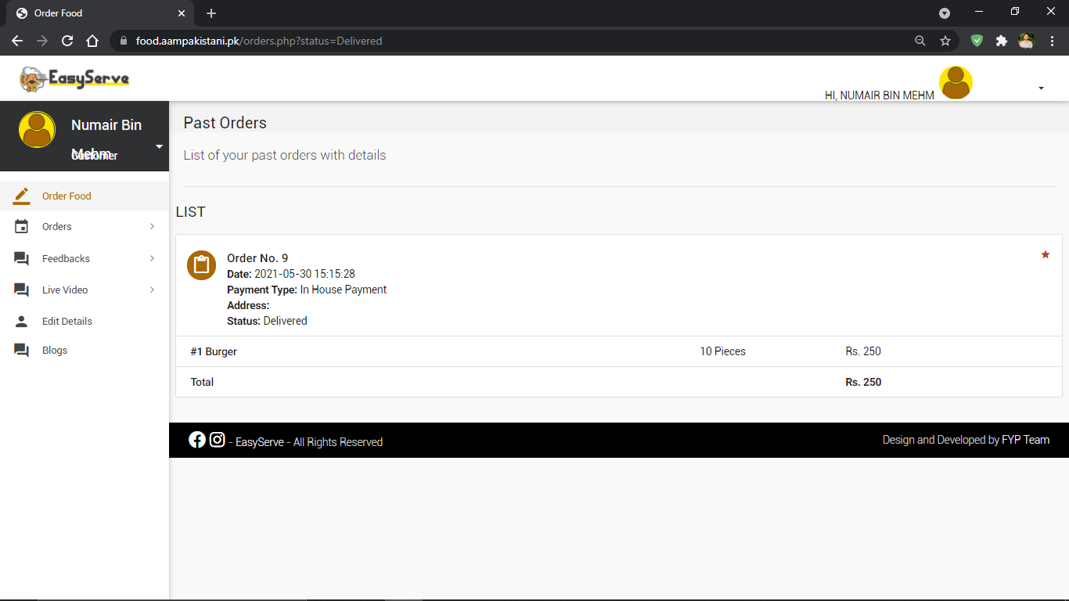**Delivered Orders**

***Figure 13: Delivered Orders***

* 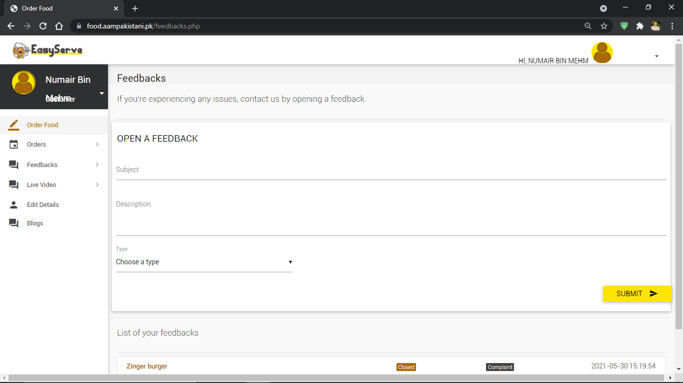**Feedback Screen**

***Figure 14: Feedback Screen***

* **Live Video**

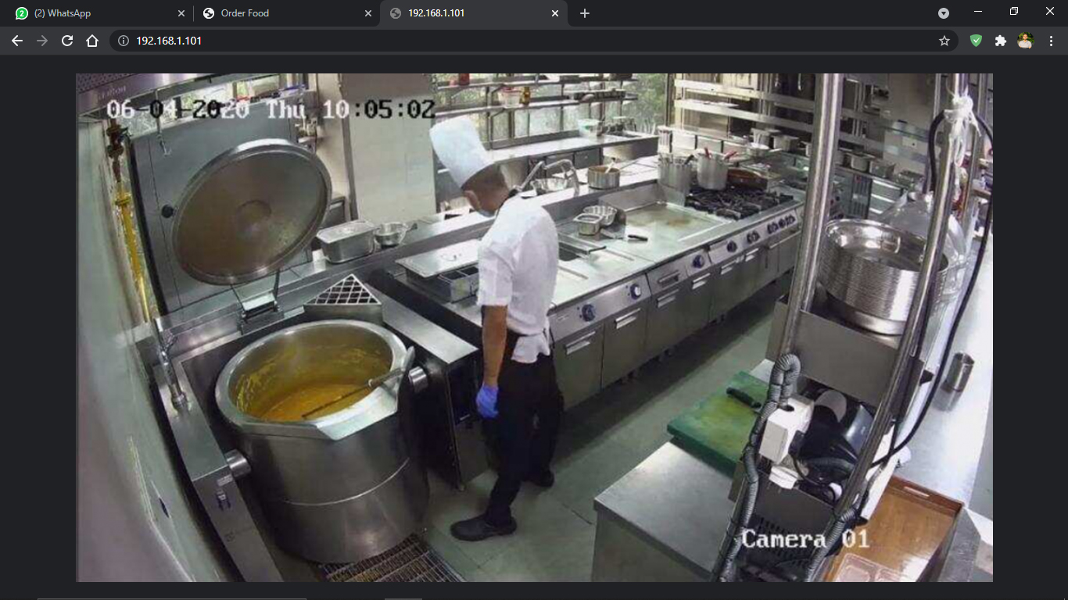

***Figure 15: Live Video***

* **Edit Details**

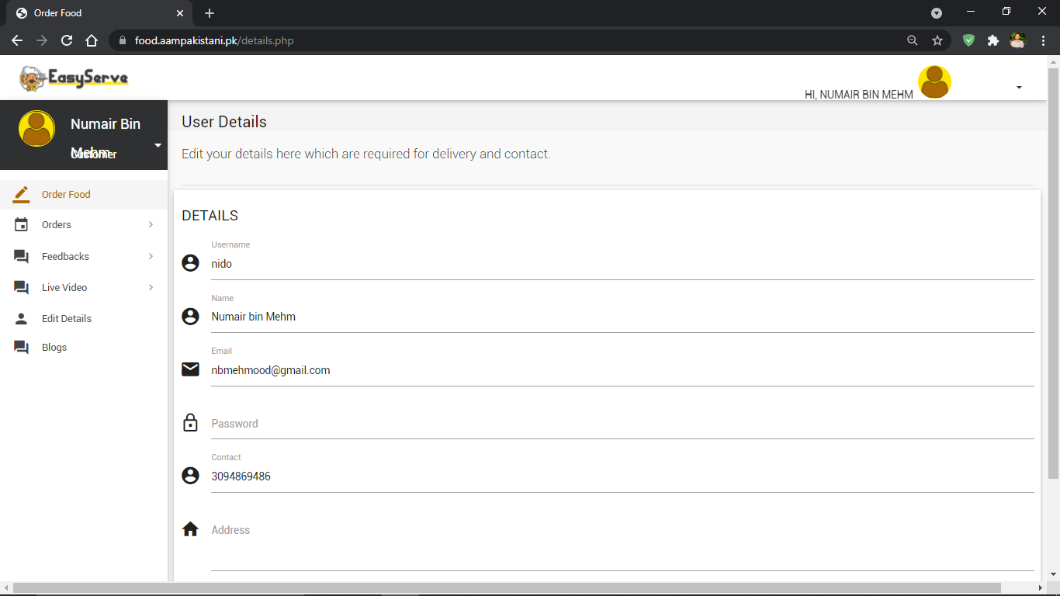

***Figure 16: Edit Details***

* **Blog Page**

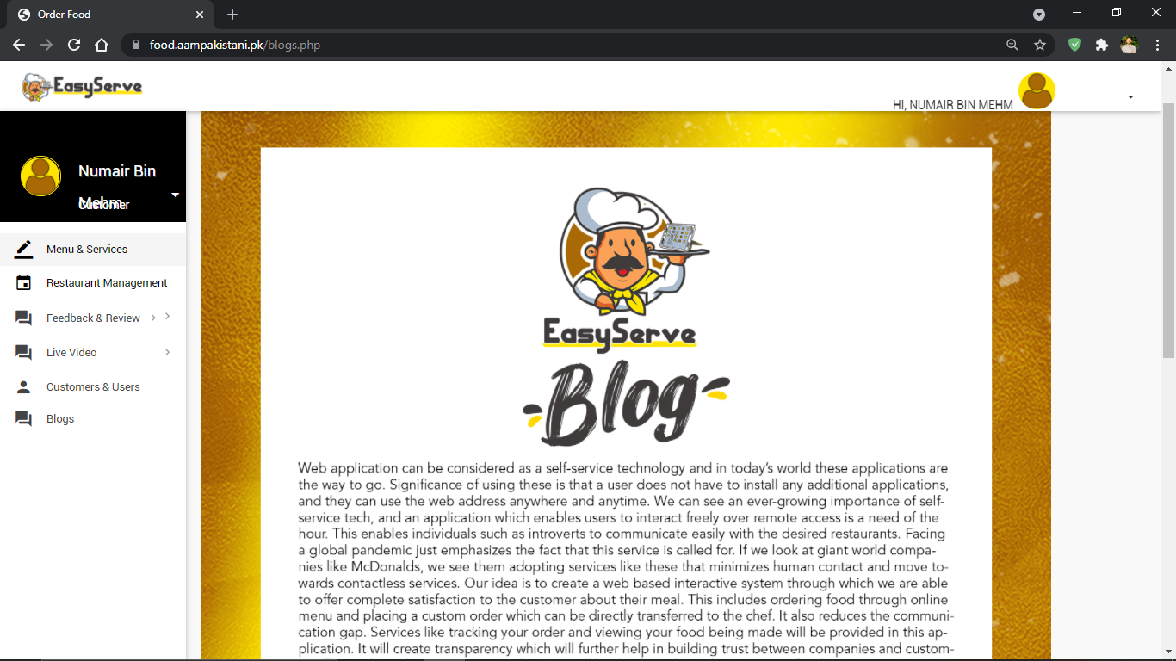

***Figure 17: Blogs Page***

* **Confirm Order Screen**

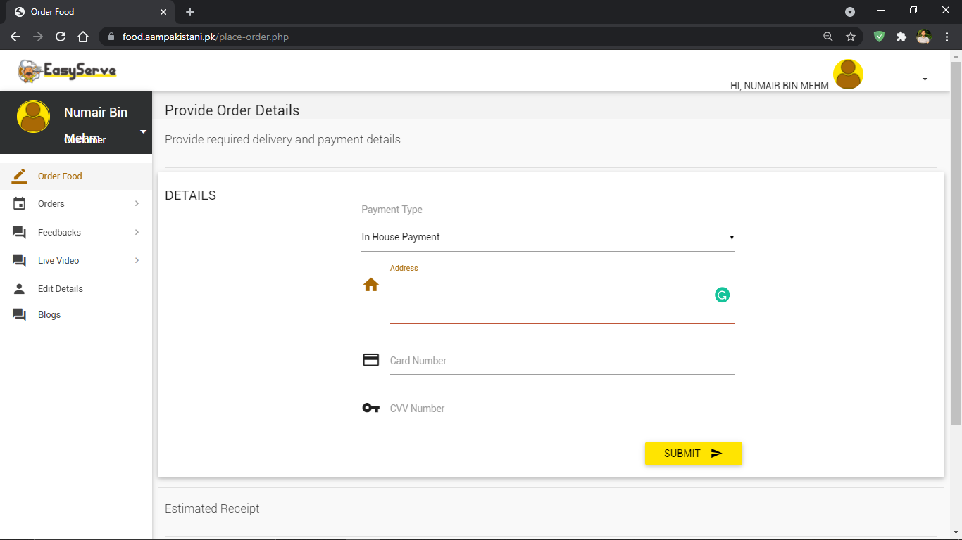

***Figure 18: Confirm Order Screen***

* **Live Chat Screen**

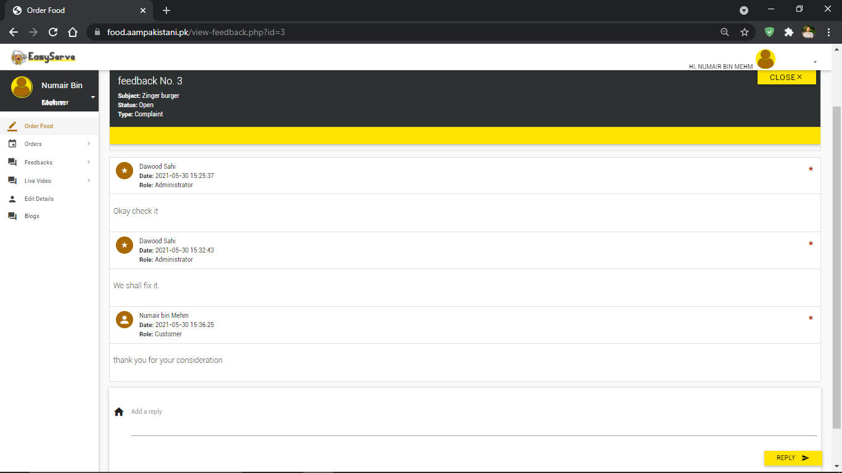

***Figure 19: Live Chat Screen***

* **Admin Dashboard**

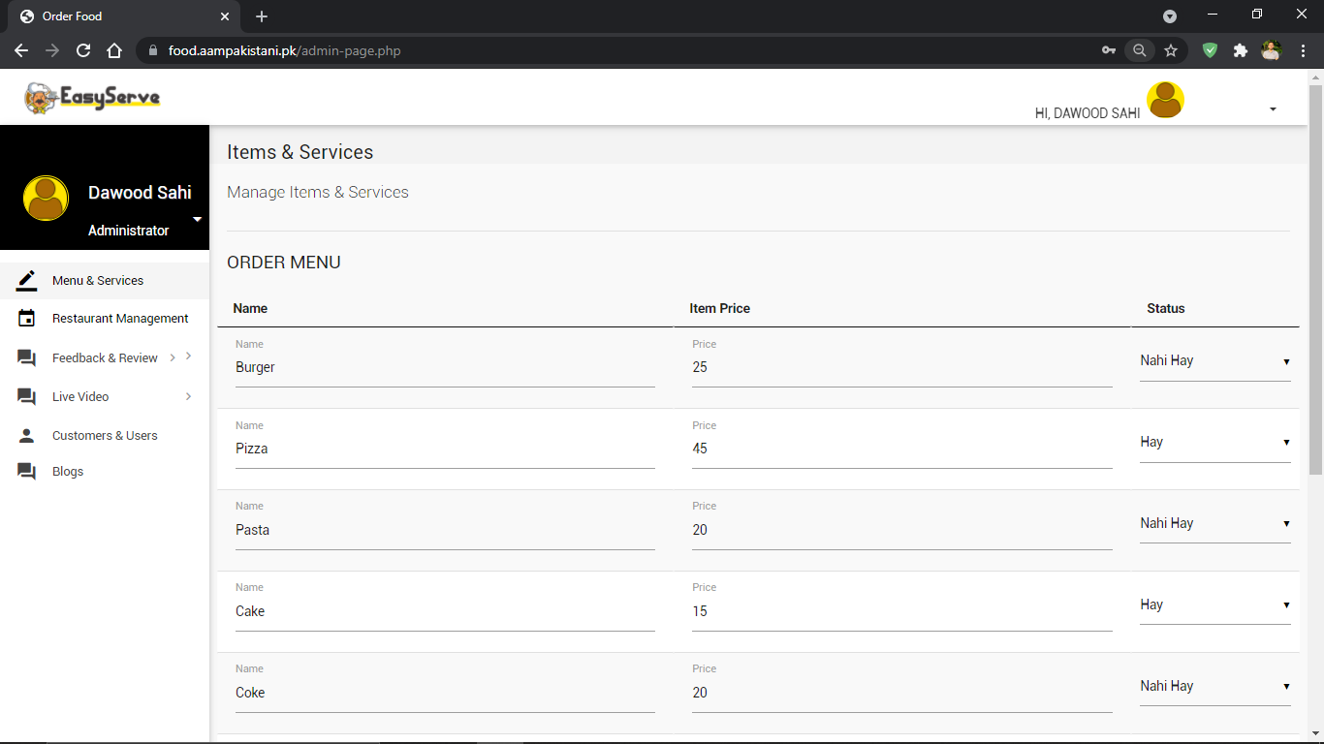

***Figure 20: Admin Dashboard***

* **All Orders Feed**

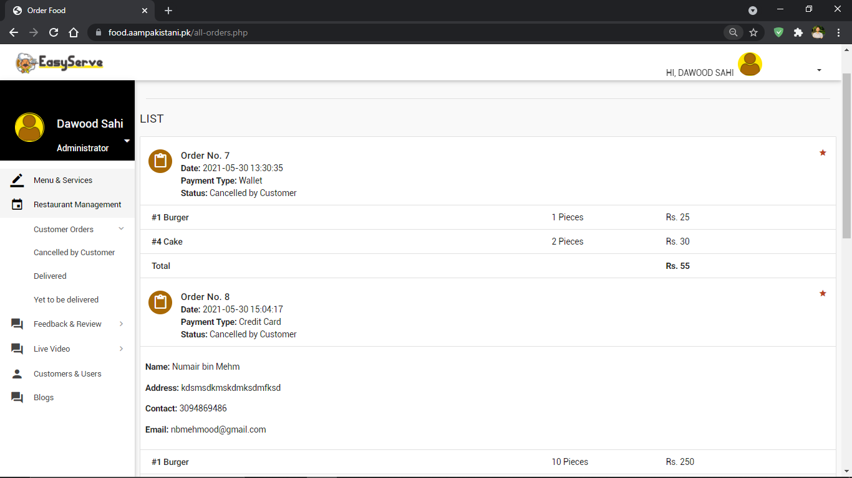

***Figure 21: All Order Feed***

* 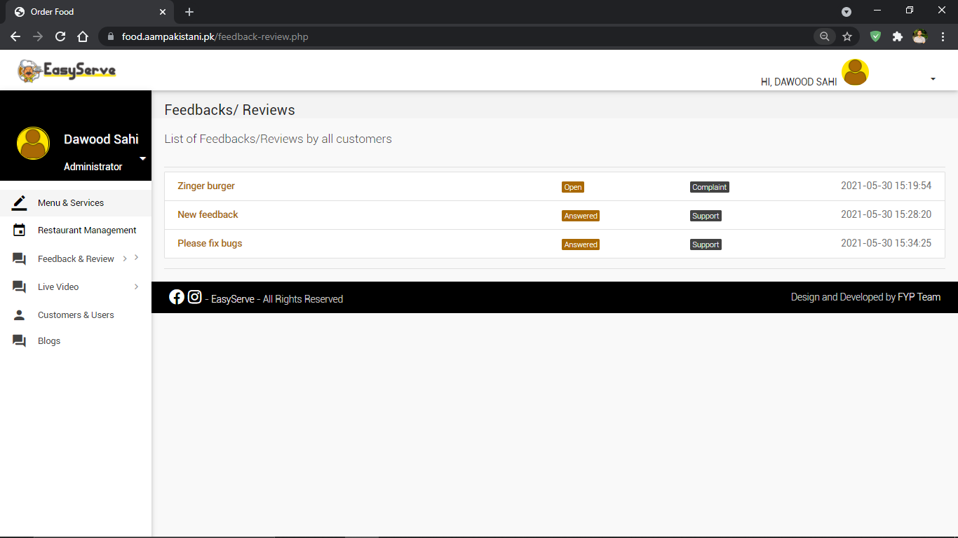**Feedback/Reviews Screen**

***Figure 22: Feedback/Reviews Screen***

* 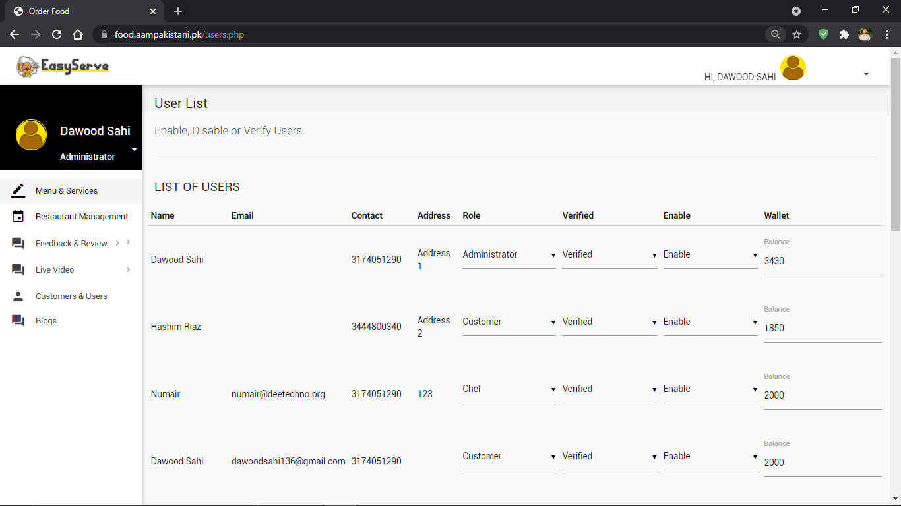**User Verification Screen**

***Figure 23: User Verification Screen***

#### 3.7 Other Design Details

Deployment: (Web / Local Host)

**1**- Base Server Tools

- XAMPP (If LocalHost Environment)

- WAMP (If LocalHost Environment)

- Web Hosted Server (Windows/Linux Based)

**2**- DNS Tools

• Localhost Deployment

• Domain Tools & Extensions (nameservers setup I nameservers redirection I port setup I port forwarding etc.)

**3**- Database Tools

• myphpadmin

• Remotesql

**4**- Frontend Tools

• Custom I Open source - Theme I Ul Interface

• Supportive Web Extensions I Plugins Compatible with the CMS

• Building Tools

• E-commerce Environment Integration (Custom/Open source)

• E-com Modules & Extensions

• Web Forms, Review/Feedback Support

### Chapter 4. Test Specification and Results

#### 4.1 Test Case Specification

**Test case 1: Signup (Admin)**

|  |  |
| --- | --- |
| **Identifier** | TC-1 |
| **Related requirements(s)** | UC-1 |
| **Short description** | The admin will provide it’s credentials for registration and if the credentials does not exist in the database the admin will get message of success |
| **Pre-condition(s)** | The provided credentials should be unique. |
| **Input data** | Username  Name  Email  Password  Phone Number |
| **Detailed steps** | The admin will provide it’s credentials and will click the join our family button. The database will check if the credentials are unique then the admin be registered successfully |
| **Expected result(s)** | The admin is registered on the website |
| **Post-condition(s)** | The admin is signed up successfully and will be redirected to login page |
| **Actual result(s)** | The admin is signed up |
| **Test Case Result** | PASS |

**Table 17: TC-1(Sign Up (Admin))**

**Test case 2: Signup (User)**

|  |  |
| --- | --- |
| **Identifier** | TC-2 |
| **Related requirements(s)** | UC-2 |
| **Short description** | The user will provide it’s credentials for registration and if the credentials does not exist in the database the admin will get message of success |
| **Pre-condition(s)** | The provided credentials should be unique. |
| **Input data** | Username  Name  Email  Password  Phone Number |
| **Detailed steps** | The user will provide it’s credentials and will click the join our family button. The database will check if the credentials are unique then the admin be registered successfully |
| **Expected result(s)** | The user is registered on the website as a customer |
| **Post-condition(s)** | The user is signed up successfully and will be redirected to login page |
| **Actual result(s)** | The user is signed up |
| **Test Case Result** | PASS |

**Table 18: TC-2(Sign Up (User))**

**Test case 3: Login successful**

|  |  |
| --- | --- |
| **Identifier** | TC-3 |
| **Related requirements(s)** | UC-3 |
| **Short description** | The system logs in the user with correct credentials |
| **Pre-condition(s)** | Databases have the record of user |
| **Input data** | Username  Password |
| **Detailed steps** | The user provides right credentials and click dine in now. The database will check if the credentials are in it and will let user to sign in. |
| **Expected result(s)** | The user logs into the website |
| **Post-condition(s)** | The user is logged in and will be directed to dashboard |
| **Actual result(s)** | Successful login |
| **Test Case Result** | PASS |

**Table 19: TC-3(Login Successful)**

**Test case 4: Unsuccessful Login**

|  |  |
| --- | --- |
| **Identifier** | TC-4 |
| **Related**  **requirements(s)** | UC-1, UC-2 |
| **Short description** | The user enters the wrong credentials and press dine in |
| **Pre-condition(s)** | The database does not have the record of the username and password |
| **Input data** | Username  Password |
| **Detailed steps** | The user enters it’s username and password and tries to login. The database check that the credentials does not exists and will give the user error message |
| **Expected result(s)** | Log in was unsuccessful |
| **Post-condition(s)** | The user is prompt to try again or sign up in case of new user |
| **Actual result(s)** | Unsuccessful login |
| **Test Case Result** | PASS. |

**Table 20: TC-4(Unsuccessful Login)**

**Test case 5: Add Item in Menu**

|  |  |
| --- | --- |
| **Identifier** | TC-4 |
| **Related requirements(s)** | UC-5 |
| **Short description** | Admin will login to the dashboard to access their menu |
| **Pre-condition(s)** | The menu is updated |
| **Input data** | Food item |
| **Detailed steps** | The admin will login and will be directed to the restaurant dashboard.  The admin will add an item in the menu.  The item will be updated to all the customers |
| **Expected result(s)** | The user will get the list of reviews |
| **Post-condition(s)** | The user will get the list of reviews |
| **Actual result(s)** | The user gets the expected reviews |
| **Test Case Result** | PASS |

**Table 21: TC-5(Add Item in Menu)**

**Test case 6: Manage Chef.**

|  |  |
| --- | --- |
| **Identifier** | TC-6 |
| **Related**  **requirements(s)** | UC-6 |
| **Short description** | The admin will be able to manage chef of the restaurant by adding them aur deleting a entry |
| **Pre-condition(s)** | The admin logs into the restaurant dashboard successfully |
| **Input data** | Name  Number  Time |
| **Detailed steps** | The admin will open the chef panel and will add a new chef into the restaurant database.  The chef will be added successfully. |
| **Expected result(s)** | Chef added successfully |
| **Post-condition(s)** | In order to add a chef the provided credentials are unique |
| **Actual result(s)** | Chef is added |
| **Test Case Result** | PASS |

**Table 22: TC-6(Manage Chef)**

**Test Case 7: Order Placement**

|  |  |
| --- | --- |
| **Identifier** | TC-7 |
| **Related**  **requirements(s)** | UC-7 |
| **Short description** | The item from the menu is ordered |
| **Pre-condition(s)** | The item is selected from the menu of the restaurant |
| **Input data** | Selecting the item |
| **Detailed steps** | The user will select the restaurant. Menu will be shown to the user. The user will select the item from the menu. |
| **Expected result(s)** | The item from the menu will be added to cart for chef to prepare |
| **Post-condition(s)** | Any item is selected from the menu |
| **Actual result(s)** | Item is selected |
| **Test Case Result** | PASS |

**Table 23: TC-7(Order Placement)**

**Test Case 8: Tracking**

|  |  |
| --- | --- |
| **Identifier** | TC-8 |
| **Related**  **requirements(s)** | UC-8 |
| **Short description** | The customer will be able to track their food via website |
| **Pre-condition(s)** | Customer order in placed |
| **Input data** | Tap on track order |
| **Detailed steps** | When user will place order by confirming it. They will click on track button to track their order. |
| **Expected result(s)** | Tracker shows customer’s food being prepared |
| **Post-condition(s)** | The order is being prepared and ready to track |
| **Actual result(s)** | The website shows the tracking process to user |
| **Test Case Result** | PASS |

**Table 24: TC-8(Tracking)**

**Test Case 9: Feedback**

|  |  |
| --- | --- |
| **Identifier** | TC-9 |
| **Related**  **requirements(s)** | UC-9 |
| **Short description** | The customer gives feedback to chef and restaurant |
| **Pre-condition(s)** | Customer have placed the order |
| **Input data** | Customer inputs the feedback |
| **Detailed steps** | After receiving the order, the customer will have an option to give feedback to the chef and the restaurant. On finishing they will open feedback tab and will give their feedback |
| **Expected result(s)** | Feedback is sent to chef and restaurant |
| **Post-condition(s)** | Customer order is complete |
| **Actual result(s)** | Feedback is received |
| **Test Case Result** | PASS |

**Table 25: TC-9(Feedback)**

**Test Case 10: Bill**

|  |  |
| --- | --- |
| **Identifier** | TC-10 |
| **Related**  **requirements(s)** | UC-9 |
| **Short description** | Bill is generated after the order completion |
| **Pre-condition(s)** | Customer order is complete |
| **Input data** | Feedback |
| **Detailed steps** | The customer will finish giving the feedback. Then they will be asked if they want to check out. A bill will be generated and a copy will also be sent to the customer’s email |
| **Expected result(s)** | Bill is generated |
| **Post-condition(s)** | Order is complete |
| **Actual result(s)** | Bill is generated and sent to customer for payment |
| **Test Case Result** | PASS. |

**Table 26: TC-10(Billing)**

#### 4.2 Summary of Test Results

|  |  |  |  |  |
| --- | --- | --- | --- | --- |
| **Module**  **Name** | Test cases run | Number of  defects found | Number of defects corrected so far | Number of defects still need to be corrected |
| **Signup** | TC-1, TC-2 | None | None | None |
| **Login** | TC-3, TC-4 | None | None | None |
| **Add Items** | TC-5 | None | None | None |
| **Manage Chef** | TC-6 | None | None | None |
| **Order Placement** | TC-7 | None | None | None |
| **Tracking** | TC-8 | None | None | None |
| **Feedback** | TC-9 | None | None | None |
| **Billing** | TC-7, TC-8, TC-9, TC-10 | None | None | None |

**Table 27: Summary of All Test Results**

### 

### Chapter 5. Conclusion and Future Work

#### 5.1 Project summary

Web applications have countless advantages, especially Easy Serve. This web application is especially useful and essential during the era of Covid-19, in which most people prefer to place food orders online rather than placing them in person. It is also extreme user friendly as no additional applications are required in order to place an order and can be accessed by anyone. It is also extremely convenient for introverted people who prefer not to interact with the waiter regarding their order, and instead can simply place their order with customization options through Easy Serve. Other than the decreased communication gap, Easy Serve offers a unique opportunity to its users to actually view their food while it’s being prepared. Not only is this experience appealing, it also reassures customers that their order is being prepared under hygienic conditions. In this way, it also keeps everything in check and the customer’s full satisfaction is achieved if they are updated through each step of their order. The transparency and intimacy involved in viewing your order getting prepared and other features, for example customization of the order and the opportunity to interact with the cook via the web app, ensures its success.

Our objective is the full satisfaction and convenience of our customers. This is ensured through the live streaming of the order being prepared, as well as through the fact that the order is contactless. It also allows individuals to give feedbacks regarding their order, which ensures a healthy customer interactive experience. It also ensures restaurants stay in check regarding the quality and taste of their food.

Easy Serve leaves no room for miscommunications and wrong orders being placed, and leaves little room of confusion for the customer, all which occasionally occur in manual placement of orders through a waiter.

Conclusively, Easy Serve is an efficient and an extremely user friendly web application which ensures the satisfaction and pleasant experience of its customers, and at the same time is extremely essential due to the current pandemic situation.

#### 5.2 Problems faced and lessons learned

#### We encountered several challenges during the course of our academic year, while working on our project. In light of the ongoing pandemic, it was also quite difficult to find advisors for our project due to the communication gap as adjusting to an online semester is difficult and time consuming. Eventually, our struggle seemed to pay off when we managed to convince Ma’am Saara and Sir Gadhaun to become our primary advisor and secondary advisor respectively.

#### While working on our project, two of our members contracted the coronavirus which of course disrupted the speed by which we were going. However, because of our understanding and highly supportive advisors we quickly got through this difficult phase and started working on our project with the same motivation and zeal. Our journey was not without obstacles. For example, we had a tough time implementing the code, however this soon was resolved. We learned a lot during our final year project, including how to efficiently put effort as a team member as well as time management skills. It was quite an experience as we realized the importance of working towards a single goal as a team, and we could only achieve this goal by believing in ourselves and making sure nothing disrupts our determination.

#### 5.3 Future work

The plan is to take this concept into the professional life and make it as one of the top web application dining in system in Pakistan’s food Industry.

### References

[1] JennelynAbahin “Sales and Inventory System of Edmar Marketing, “2013.

[2] FlorDayuha “Sales and Inventory System for BC Home Furnishing and Appliance Center,” March 2013.

[3] Francesco Constantino “Multi-echelon, Multi-indenture Spare Parts Inventory Control Subject to System Availability and Budget Constraints,”Nov. 2013.

[4] Hospitality Solutions International (2013). Table Management System; Complete control from the

moment guests are greeted, http://dnn.hsisolutions.com/Solutions/Consumer-Solutions/TableManagement-and-Reservation-Solutions.aspx, (Date Accessed: 21-01-2021).

[5] Maitredee360 (2011). Web-Based Hotel Booking Software, www.urlm.com, (Accessed Date: 22-08-2014).

[6] Valeria Minghetti (2003). Building Customer Value in the hospitality Industry: Towards the Definition of a Customer-Centric Information System, Journal of Information and Technology and Tourism, Volume. 6,

Page 141-152.

[7] Karl W. Wober (2003). Information Supply in Tourism Management by Marketing Decision Support Systems, Journal of Tourism Management, Volume 24, Page 241-255.

[8] Mohammed El Dief (2012). Determinants of Environmental Management in the Red Sea Hotels:

Personal and Organisational Values and Contextual Variables, Journal of Hospitality and Tourism

**Appendix A Glossary**

1. User: The customer who wants to use the application for reservation and order food for delivery.
2. Restaurant: The eatery providing their menus to the user.
3. Registered user: The user who has signed up to get access to the features of the application.
4. Admin: Team who is maintaining the application and managing the data.
5. Chef: The cooks hired by the restaurants.
6. Live feed: The kitchen feed showed to the customer

**Appendix B Deployment/Installation Guide**

This web application can be deployed using WebLogic Server Administration Console

When WebLogic Server is running in development mode, Web applications that are copied into the applications/ directory are automatically deployed.

### Appendix C User Manual

* **Login Page**

The user will be shown this screen when first they will open our web address at <https://food.aampakistani.pk/login.php>. Here they will be asked to login if they are registered as an administrator or the customer. If not, then the will be given the option of registering themselves as a customer to any restaurant platform. After registering with name, email, username, mobile number and password. The customer will be verified by the administration so that they can order in their restaurant.

***Figure 24: Login Page (Appendix)***



* **Registration Screen**

This screen will be shown to the user who wants to register as a new user and will have to provide the data in order to login to the website.

***Figure 25: Registration Page (Appendix)***

* **Logo**

This is a responsive logo as it will take the user to the main page which is the menu page of the restaurant from where a customer can order food.

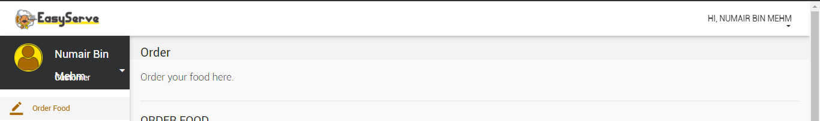

***Figure 26: Logo (Appendix)***

* **Logout Icon**

At the top right the user is greeted with their name and when they open the drop down menu, they have an option to logout from the server.

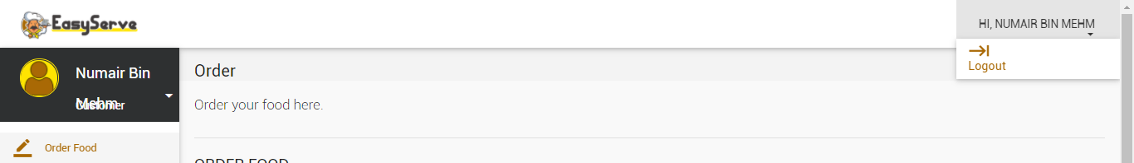

***Figure 27: Logout Icon (Appendix)***

* **Side Toolbar**

This toolbar will help user navigate with ease on the website. They have the option to go to any functionality with one click only.

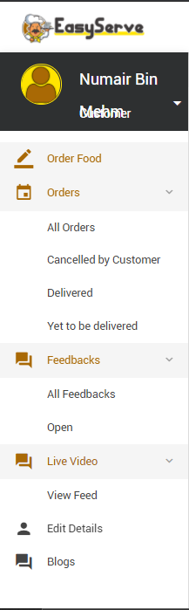

***Figure 28: Side Toolbar (Appendix)***

* **Ordering an item**

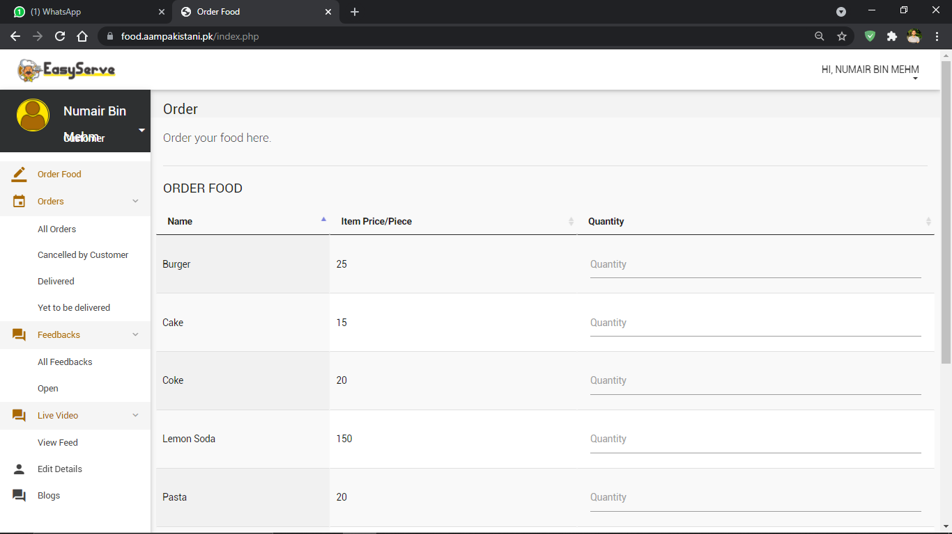At order food screen the user will have all the options available to order food from the restaurant

***Figure 29: Ordering an Item (Appendix)***

After deciding the order thecustomer will have the option to add any specific instruction about their order and they will place the order.

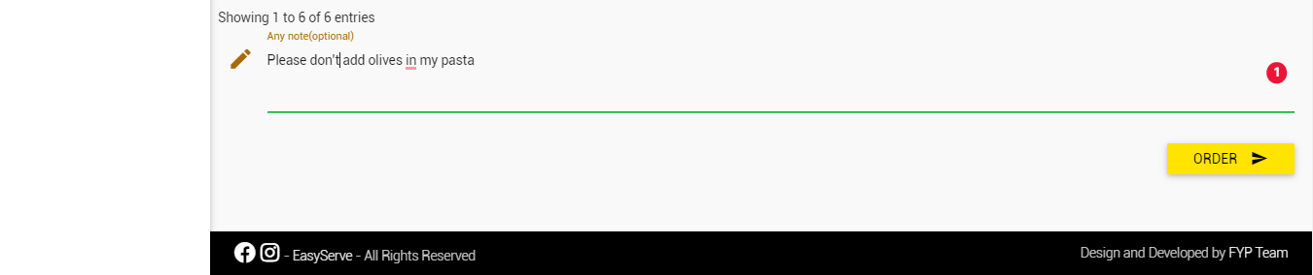

***Figure 30: Confirm Order (Appendix)***

* **Payment Method**

After confirming the order the customer will be asked the payment method and their table number. Now the customer can place the order.

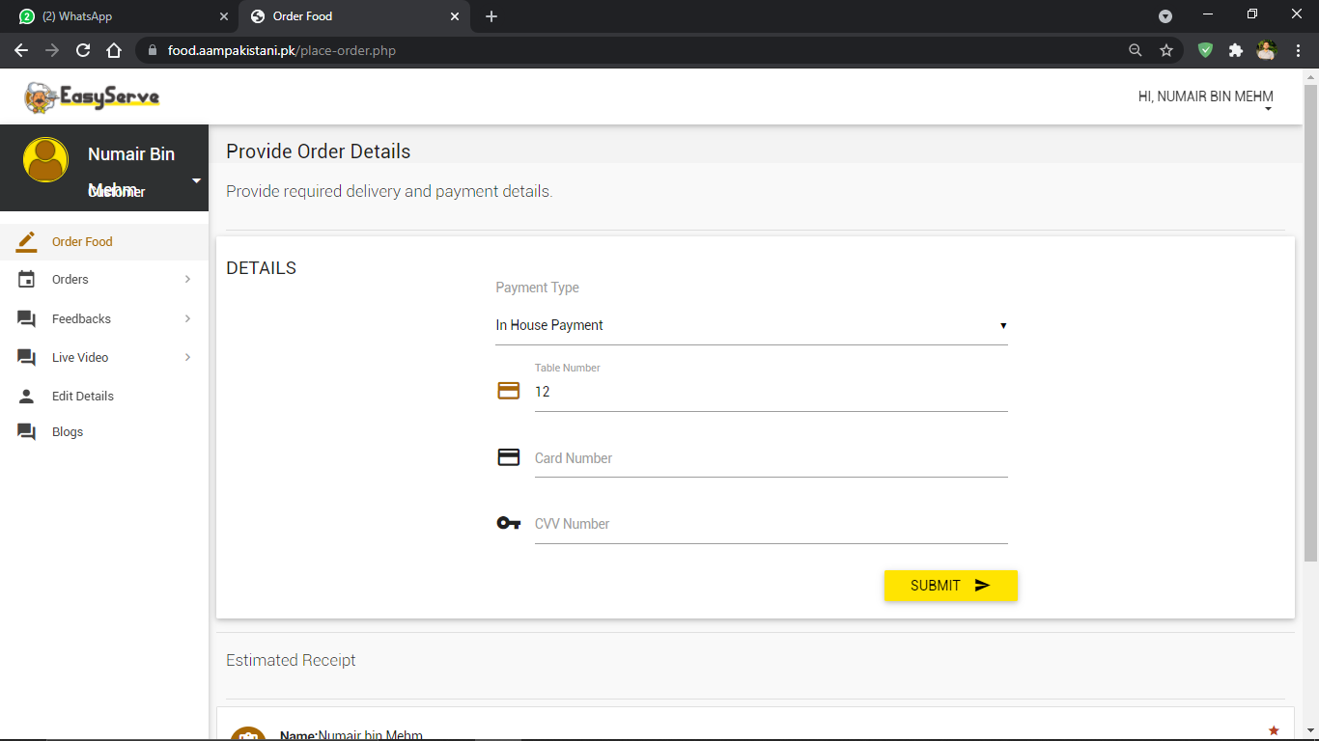

***Figure 31: Payment Method (Appendix)***

* **Delivered Orders**

****After confirming the order, the status of the order will be shown to the customer in their order field.

***Figure 32: Delivered Orders (Appendix)***

* **Feedback Screen**

The customer will have the option to leave a feedback to the restaurant through feed back option. This is where they can also have chat with the administration of the restaurant.

***Figure 33: Feedback Screen (Appendix)***

* **Live Feed**

When the order of customer will be in progress the customer will have the option to view the live feed of the kitchen to see their food being made

***Figure 34: Live Feed (Appendix)***

* **Edit Details**

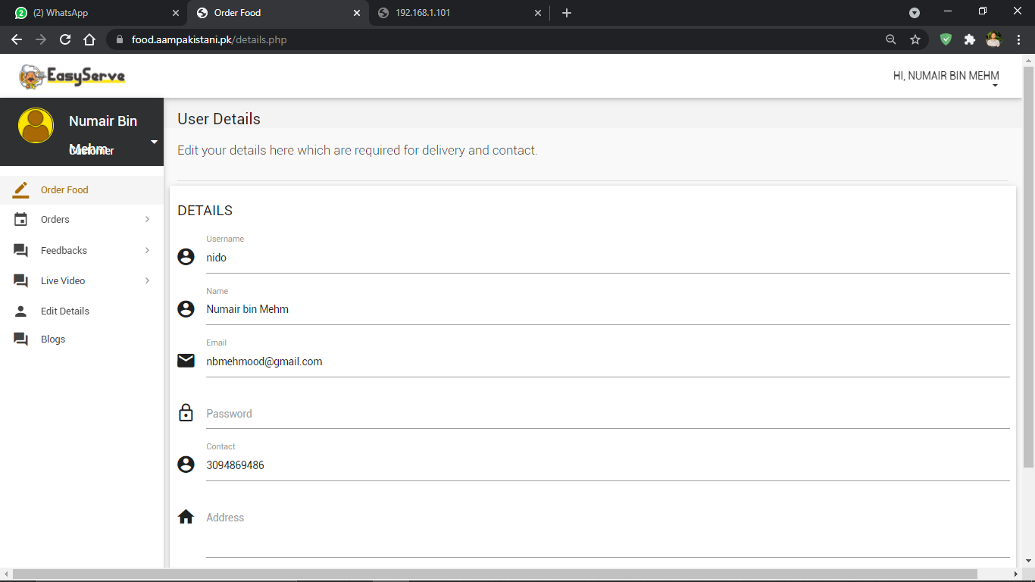The edit details tab will give the user access to their personal information which they can change.

***Figure 35: Edit Details (Appendix)***

* **Facebook Page**

Footer contains the link to our Facebook page.



***Figure 36: Facebook Page (Appendix)***

* **Instagram page**

Footer contains the link to Instagram page also.



***Figure 37: Instagram Page (Appendix)***

* **Blog**

The user will have the access to Easy Serve exclusive blog also.

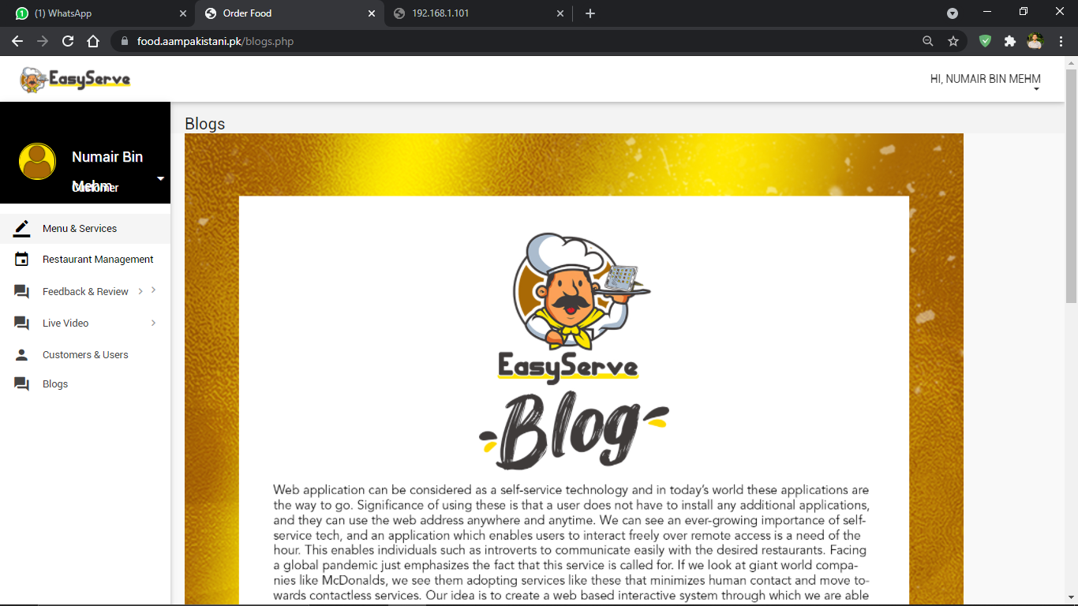

***Figure 38: Blog (Appendix)***

* **Admin Dashboard**

This is the administrator dashboard in which they can add item in their restaurant menu.

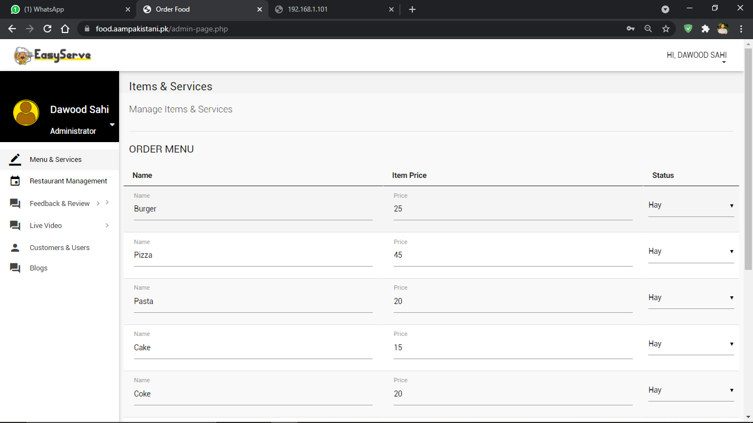

***Figure 39: Admin Dashboard (Appendix)***

* **User Verification**

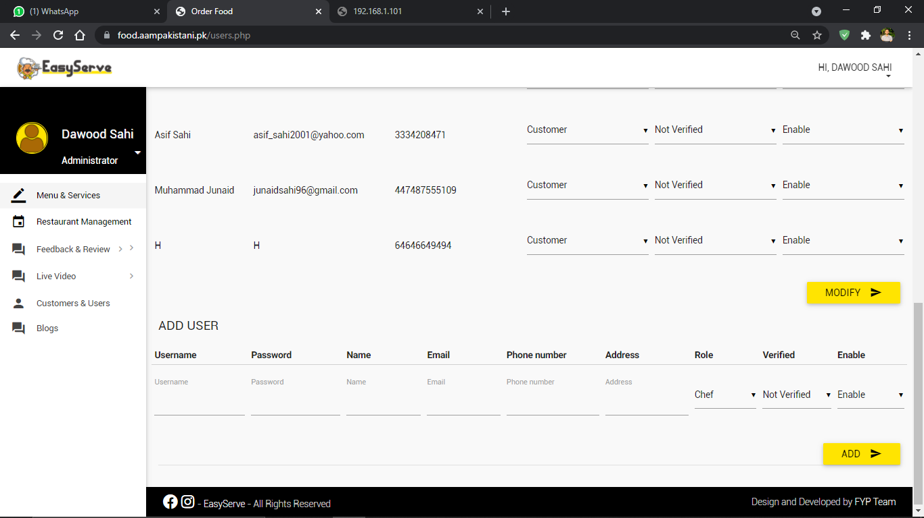This tab will allow the admin to verify the user as customers, administrator or chef

***Figure 40: User Verification (Appendix)***

### Appendix D Student Information Sheet

|  |  |  |  |  |
| --- | --- | --- | --- | --- |
| Roll No | Name | Email Address (FC College) | Frequently  Checked Email Address | Personal  Cell Phone Number |
| 21-10472 | Dawood Sahi | 21-10472@formanite.fccollege.edu.pk | FCC email address | 03174051290 |
| 21-10202 | Hashim Riaz | 21-10202@formanite.fccollege.edu.pk | FCC email address | 03404082027 |
| 20-11237 | Numair Bin Mehmood | 20-11237@formanite.fccollege.edu.pk | FCC email address | 03094869486 |

### Appendix E Plagiarism Free Certificate

This is to certify that, I am ________________________ S/D/o _______________________, group leader of FYP under registration no _________________ at Computer Science Department, Forman Christian College (A Chartered

University), Lahore. I declare that my Final year project report is checked by my supervisor and the similarity index is ________% that is less than 20%, an acceptable limit by HEC. Report is attached herewith as Appendix F. To the best of my knowledge and belief, the report contains no material previously published or written by another person except where due reference is made in the report itself.

Date: 3rd June 2021 Name of Group Leader: ________________________ Signature: _____________

Name of Supervisor: Ma’am Saara Asif Co-Supervisor (if any): Sir Gadhaun Aslam

Designation: _____________________ Designation: _____________________

Signature: _____________________ Signature: _____________________

Senior Project Management Committee Representative: _____________________

Signature: _____________________

### Appendix F Plagiarism Report